|  |  |
| --- | --- |
|  | Foundation Activity 8 |

DC Motors

|  |  |
| --- | --- |
| DC motors often look like this: | In a circuit diagram we draw them like this: |
| C:\Users\Harryp\MEGA\Surface Pro 2\Nepal\Himalayan Makers Guild\Activities\Foundation Activities\FA8 - DC Motors and Potentiometers\images\part - DC motor.jpg[[1]](#footnote-1) | C:\Users\Harryp\MEGA\Surface Pro 2\Nepal\Himalayan Makers Guild\Activities\Foundation Activities\FA8 - DC Motors and Potentiometers\images\Eagle\dcmotor.png |

Controlling rotation direction

|  |  |
| --- | --- |
| By applying a voltage to the motor wires, it will spin: | If we flip the applied voltage, the rotation direction will change: |
| C:\Users\Harryp\MEGA\Surface Pro 2\Nepal\Himalayan Makers Guild\Activities\Foundation Activities\FA8 - DC Motors and Potentiometers\images\Eagle\dcmotor_battCW.png | C:\Users\Harryp\MEGA\Surface Pro 2\Nepal\Himalayan Makers Guild\Activities\Foundation Activities\FA8 - DC Motors and Potentiometers\images\Eagle\dcmotor_battCCW.png |

Controlling Rotation Speed

The amount of current flowing through the motor determines how fast the motor will rotate. More current results in a higher speed. We can control the current using a resistor.

|  |  |
| --- | --- |
| **Faster** | **Slower** |
| C:\Users\Harryp\MEGA\Surface Pro 2\Nepal\Himalayan Makers Guild\Activities\Foundation Activities\FA8 - DC Motors and Potentiometers\images\Eagle\dcmotor_battR1.png | C:\Users\Harryp\MEGA\Surface Pro 2\Nepal\Himalayan Makers Guild\Activities\Foundation Activities\FA8 - DC Motors and Potentiometers\images\Eagle\dcmotor_battR2.png |

Potentiometer – A variable Resistor

|  |  |
| --- | --- |
| Potentiometers often look like this: | In a circuit diagram we draw them like this: |
|  |  |

There are two resistors inside, wired in series. The total resistance of the potentiometer is split between the two resistors. By turning the knob of the potentiometer, we can change how the resistance is divided between the two resistors. For example, if we use a 10kΩ potentiometer:

|  |  |
| --- | --- |
| C:\Users\Harryp\MEGA\Surface Pro 2\Nepal\Himalayan Makers Guild\Activities\Foundation Activities\FA8 - DC Motors and Potentiometers\images\Eagle\pot_middle.png | Knob centered.  Each resistor gets ½ of the total resistance |
| C:\Users\Harryp\MEGA\Surface Pro 2\Nepal\Himalayan Makers Guild\Activities\Foundation Activities\FA8 - DC Motors and Potentiometers\images\Eagle\pot_states.png | Knob turned clockwise |
| Knob turned counter-clockwise |

By connecting to pin 1 and 2, or pin 2 and 3, we get a single resistor that changes in value between approximately 0Ω and 10kΩ.

Controlling DC Motor Speed with a Potentiometer

By adding an LED to the motor, we can see voltage created by the rotating motor in the brightness of the LED:

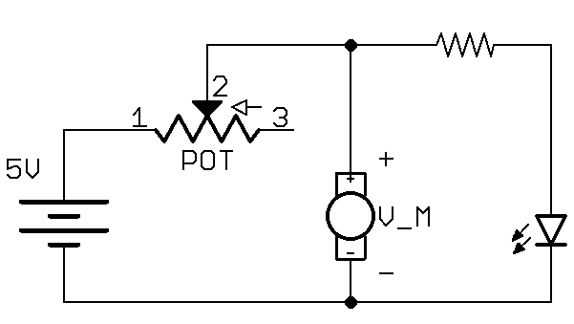

1. Part images from Fritzing [↑](#footnote-ref-1)